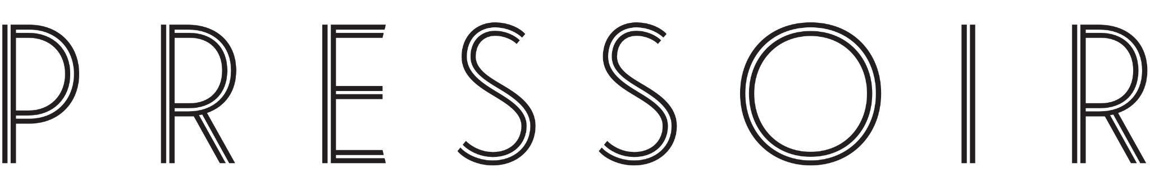

MEDIA CONTACT
Alyssa Young, MMGY Wagstaff
pressoir@wagstaffmktg.com
516.398.9274

LA PAULÉE FESTIVAL BRINGS BURGUNDY
BACK TO NEW YORK CITY
Indulge in the Wines of Burgundy Alongside Acclaimed Producers & Celebrated Chefs at the Revered Festival, Featuring Luxury Tastings, Seminars & Dinners
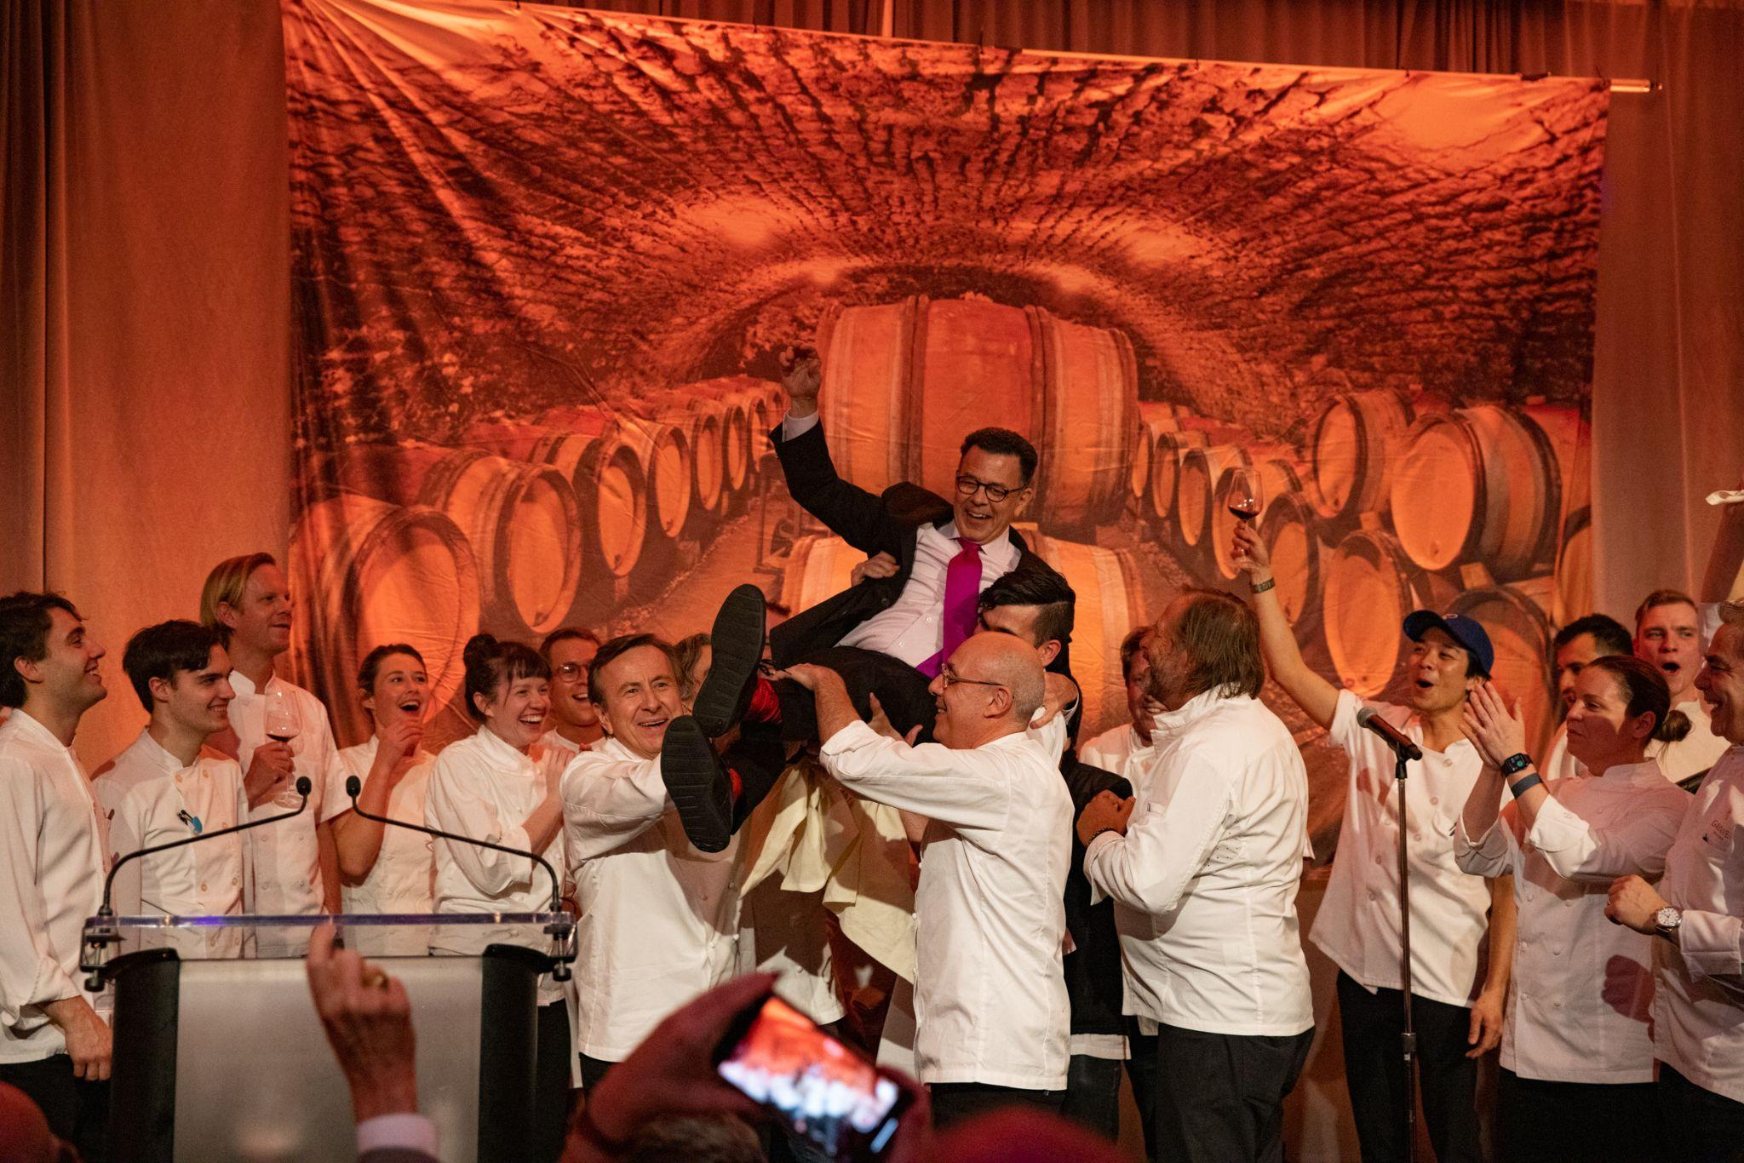
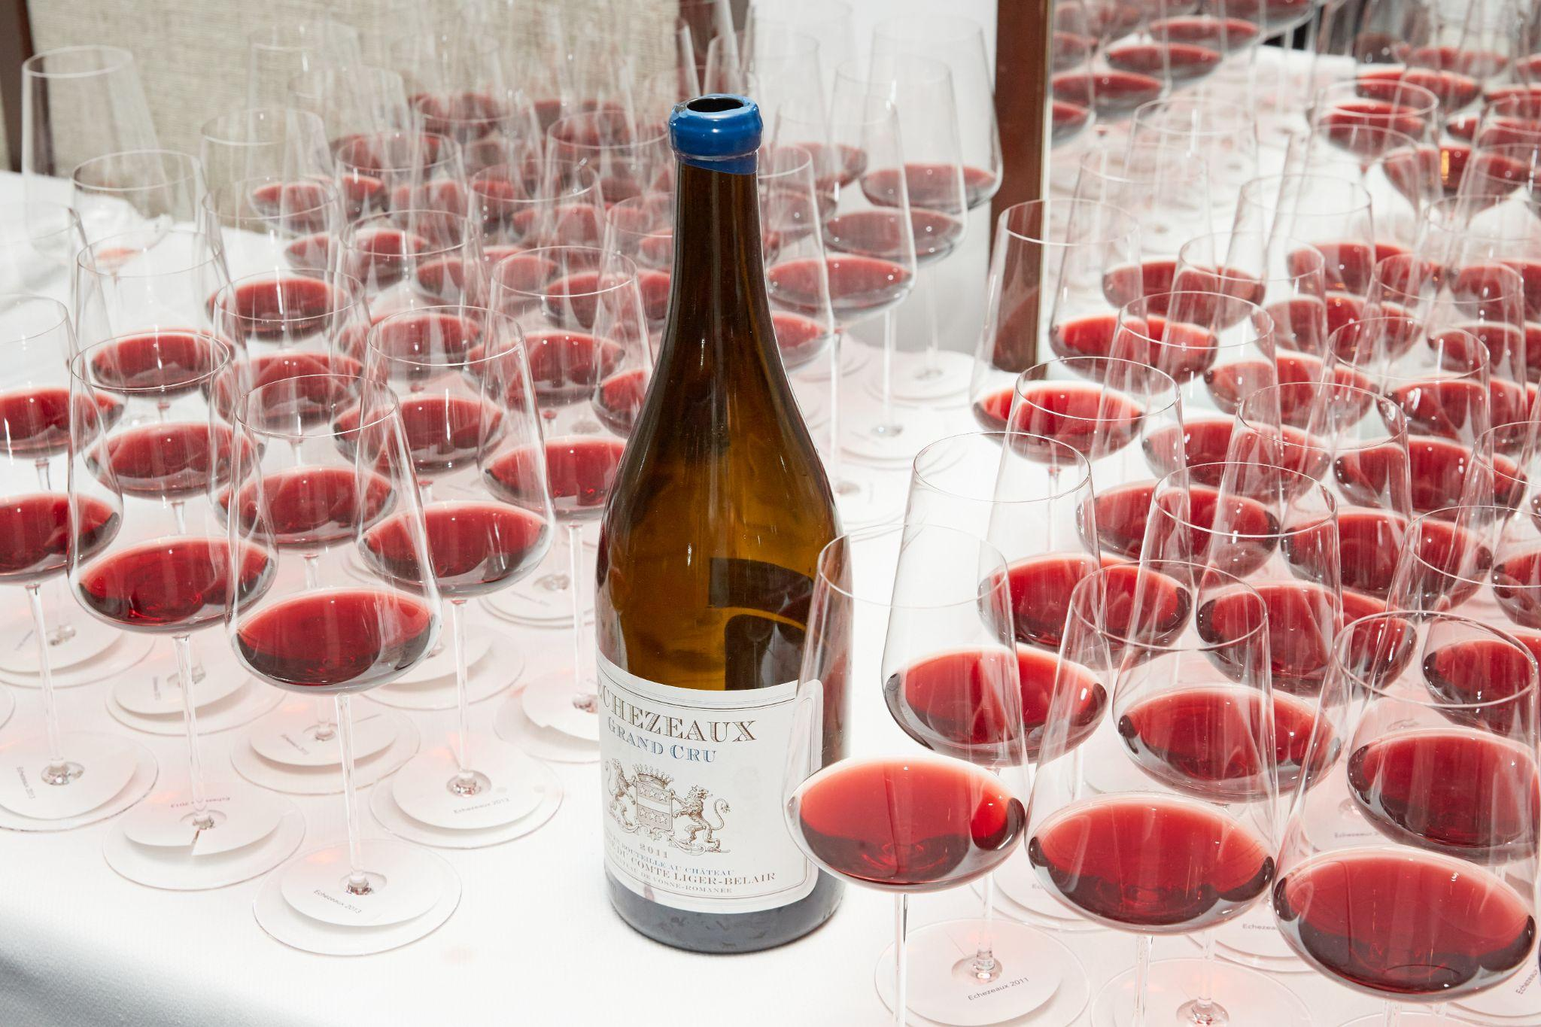

NEW YORK, JANUARY 16, 2023 – La Paulée, the internationally acclaimed celebration of Burgundy’s wine and culture, is set to return for its highly anticipated 2024 edition this February 22-23 and March 6 in New York City. The festival pays homage to the region’s rich heritage, showcasing the finest wines, cuisine, and celebrated producers, one-of-a-kind tastings, seminars, lavish dinners, and collaborations with New York’s top chefs. La Paulée is produced by world-renowned sommelier Daniel Johnnes and his organization Pressoir, the team behind top French wine festivals La Fête du Champagne and La Tablée.

After years of cultivating significant relationships with winegrowers in the region, the Pressoir team has personally invited Burgundy’s finest producers to present their wines at this year’s La Paulée. Wine lovers of all types – from serious collectors to curious novices – can indulge their passion for the intensely fragrant and fruity flavors that are embodied by Burgundian wines.

The New York La Paulée festival is inspired by Burgundy’s own celebration held at the end of each grape harvest: an extravagant luncheon that starts at noon on Monday at the Château de Meursault and continues well into the evening. La Paulée in New York is Daniel Johnnes' homage to La Paulée de Meursault, which dates back to 1923, in an effort to transport the region’s spirit of generosity and camaraderie to American wine lovers. The first La Paulée de New York took place in March 2000; since then, the Pressoir team and guests alike have celebrated La Paulée in San Francisco, Aspen, CO, and this year, it will also be held in Los Angeles from February 27-March 2.

Tickets will be available for purchase to the general public beginning on Wednesday, January 31 at 10am ET, through the official La Paulée website. In addition, American Express Centurion Card® Members can take advantage of early ticket access beginning Tuesday, January 16 at 12pm ET, while American Express Platinum Card® Members can purchase beginning Wednesday, January 17 at 12pm ET. Both grant access to special ticket packages and exclusive experiences.

The full program of events, details, and pourings can be found at the La Paulée website. For more information and updates, follow La Paulée on Instagram.
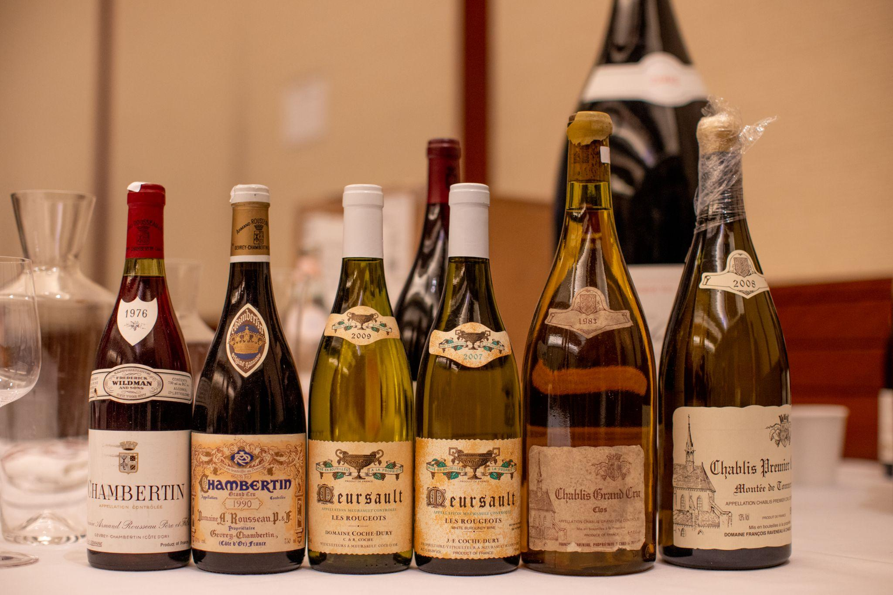

LA PAULÉE 2024 PROGRAM
Thursday, February 22
- A Natural Approach to Burgundy: a dinner featuring wines from Château de Béru, Maison Chanterêves, Le Grappin, Frédéric Cossard, & Vin Noé
The dedication to sustainable farming and organic & biodynamic viticulture has never been stronger in Burgundy than it is today. A growing movement of producers takes this philosophy a step further, adhering to a style of winemaking that espouses minimal intervention, terroir transparency, and purity of fruit. This dinner will champion the delicious wines of these hard-working and inspiring vignerons, with a selection of bottlings from Château de Béru, Frédéric Cossard, Le Grappin, Vin Noé, and Chanterêves, paired with a tasting menu from Chef Ron Yan of Parcelle Wine Bar & Tolo. Tickets will be available on 1/31 @ 12pm EST on Resy.
  - Location: Parcelle Wine Bar, 135 Divison Street, New York
  - Time: 6:30pm
  - Cost: $295
Please note that winemakers will not be in attendance for this event.

Exclusively for American Express Centurion® and American Express Platinum® Card Members. Enter the 10-digit toll-free Customer Service phone number (without spaces, dashes, or the initial “1”) from the back of your Card as a promo code on Eventbrite to unlock access to tickets for this event.

Friday, February 23
- La Paulée Off Grid: A Tasting of Burgundy’s Hidden Gems
La Paulée’s popular “Off Grid” tasting is proof positive that the joys of Burgundy can be accessible. The best way to discover all that Burgundy has to offer, this tasting will feature a selection of over 75 wines from all the major regions of Burgundy, including Chablis, Côte d'Or, Côte Chalonnaise, Mâcon, and Beaujolais, as well as a number of Aligotés, curated by acclaimed sommelier Yannick Benjamin of Harlem hotspot Contento, Hell’s Kitchen bottle shop Beaupierre, and the University Club. Enjoy fine cuisine from a selection of New York restaurants and purveyors. Connect with the sommeliers on hand who will share their picks from Burgundy and provide tips on great value wines, up-and-coming winemakers, and surprising vintages.
  - Location: 26 Bridge|26 Bridge Street, Brooklyn, NY
  - Time: 6:00pm-8:00pm
  - Cost: $150

Wednesday, March 6
- Domaine des Comtes Lafon Montrachet Dinner: An Evening with Dominique Lafon, Léa Lafon, & Pierre Lafon, sponsored by NetJets
La Paulée 2024 will close with an extraordinary evening in the company of the Lafon family – Dominique Lafon, with his daughter Léa and nephew Pierre, who together succeeded Dominique in running the family estate at the end of 2021. The Lafons have opened the estate’s cellar to provide an unprecedented lineup of the grandest of Grands Crus in Burgundy - Montrachet, of which the family owns around 0.31 of the vineyard’s 8 hectares. The mindblowing selection of wines includes no fewer than 13 vintages, back to 1986, one of Dominique’s first. The wines will be paired with Chef Ryan Hardy’s modern Italian-inspired cuisine at Legacy Records.
- Location: Legacy Records | 517 West 38th Street, New York, NY
- Time: 6:30pm Champagne Salon Reception
- Cost: $5,500

La Paulée is proud to host the greatest estates of Burgundy
Château de Béru • Bouchard Père & Fils • Maison Chanterêves • Domaine Yvon Clerget
Domaine Clos de la Chapelle • Clos de Tart • Domaine des Croix • Maison Joseph Drouhin Domaine d’Eugénie • Domaine William Fèvre • Domaine Didier Fornerol
Domaine Jean-Marie Fourrier • Domaine Génot-Boulanger • Domaine Henri Gouges
Les Hospices de Beaune • Domaine Hudelot-Noëllat • Maison Louis Jadot
Domaine Antoine Jobard • Domaine des Comtes Lafon • Domaine Hubert Lamy
Domaine Leflaive • Domaine Antoine Lienhardt • Domaine de Montille • Domaine Pierre Morey • Domaine Georges Noëllat • Domaine Ponsot • Domaine Nicolas Rossignol • Domaine Rougeot • Maison Camille Thiriet • Domaine de la Vougeraie
and featuring Les Aligoteurs, Champagne Salon & Champagne Delamotte.

###

ABOUT PRESSOIR
Founded by celebrated wine expert Daniel Johnnes, whose influence on the wine and hospitality industry is recognized far and wide, Pressoir is the country’s leading wine organization honoring the Burgundy, Champagne, and Rhône Valley regions. Pressoir originated with the first La Paulée event held in the U.S. in 2000, designed to bring the wine and culture of Burgundy to American wine lovers. Since then, the Pressoir team has built an organization that is dedicated to showcasing French wine and culture through a range of events and services.

